**Week 9 – Unit Test**

For setting up the unit test, open the desired class file and right click on class name e.g. **public class Award** and click on **Show Context Action** and then select **create test.** This will create the test file automatically.

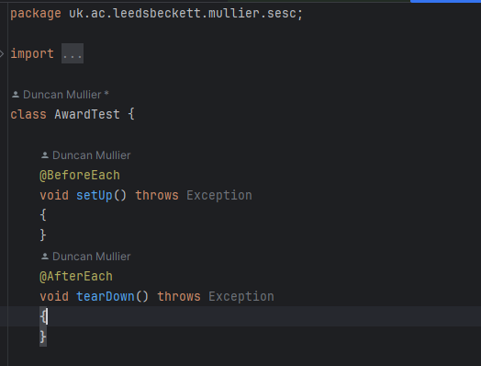

Figure : Test Class

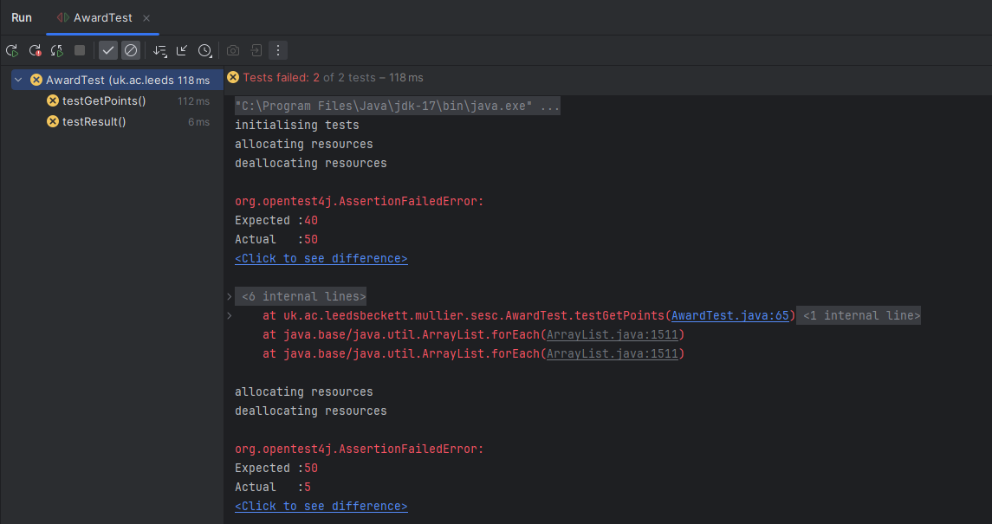

Figure : Test result

**GetPoints test Fix**

To fix GetPoints, we should start the array point index 0 instead of 1, as the arrays are 0 based index. By replacing the 1 with 0 in loop it can be fixed.

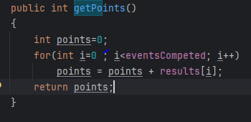

Figure : GetPoints method fix

**TestResult test fix**

We can clearly see that, points for event 5 are 50, so need to compare the same number in assertion instead of 5. By replacing 5 with 50 is going to fix the issue.

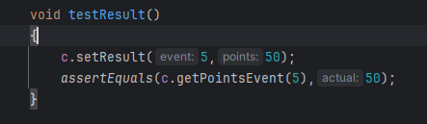

Figure : TestResult method fix

After fixing and running the test again, all of the tests are passing as expected.

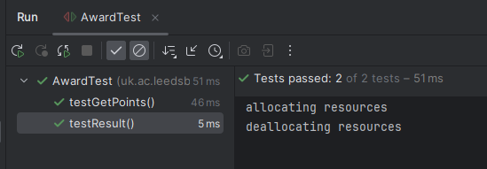

Figure : Test Results

**Adding Competitor to league**

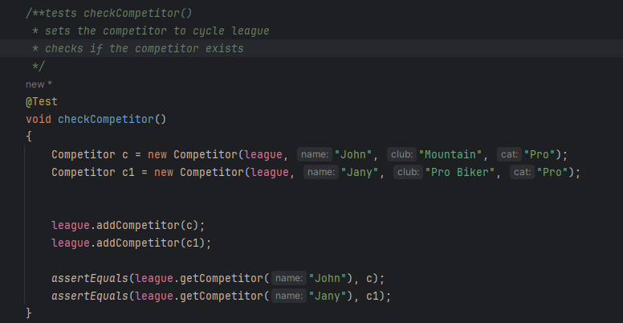

Figure : League Competitor Result

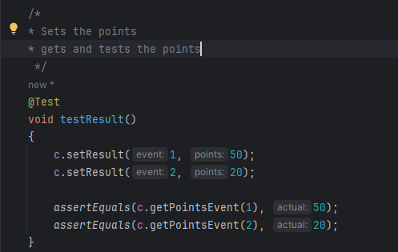

Figure : Result Test